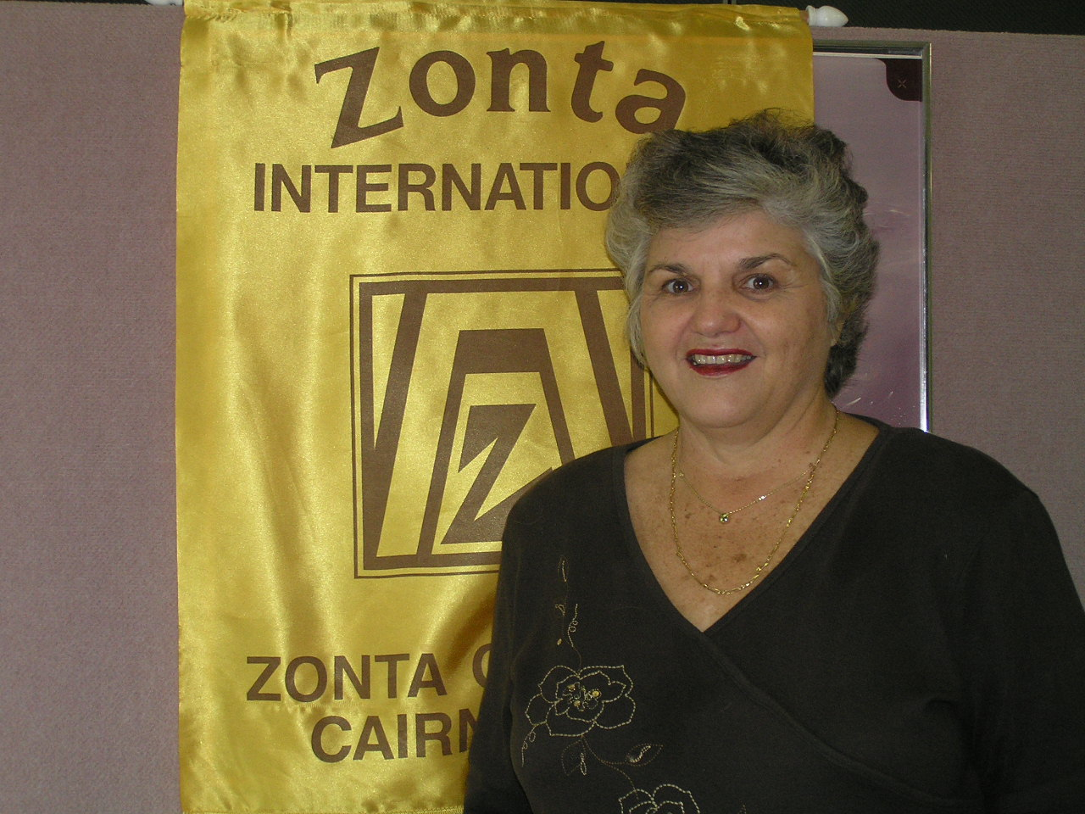

PRESIDENTS NEWSLETTER APRIL 2006
With our AGM behind us we move forward into the coming year which I hope will be one of working together and some fellowship.

To start the year off we have our Movie Night on 28th May and the early reports are that ticket sales of progressing well. I am aware that BC&C are doing plenty of advertising for this movie so lets take advantage of that and make this night a great success.

I have forwarded the nominating forms for the Townsville workshop to be on 13-14th April I am sure that we can put together a contingent of members to attend. These events are always good fun.

During the week I received a letter of resignation from Judy Durich. We wish her well and hop to see her again in the future. Also we wish Fay B. a happy birthday ( … 0th) this coming Saturday and hope that the wedding of daughter, Rebecca, on the following weekend will be a successful event. We also farewell both Wendy B. and Mrs Y. who are both traveling overseas over the next two month. Travel safe both of you.

This will be the first Newsletter by the new committee, so members please assist where you can and forward any snippets which you think of interest.

The SOW committee is to arrange a guest speaker for the coming meeting and I am sure the subject will be of interest to us all.

Your in fellowship through Zonta.

Lale M. Jones

DIARY DATES

2nd May Dinner meeting Sheridan Plaza Hotel
13-14th May Townsville workshop – Southbank Hotel
16th May Board Meeting – Yumi Smith’s Mcleod Street.
28th May Movie night The Da Vinci Code
3-4th June Relay for Life
6th June Dinner meeting – Books , CD Sale night
20th June Board Meeting
24-29th June ZI convention- Melbourne

A QUOTE TO PONDER –

The Most frightening women who do too much are those who don’t know they are doing too much until it’s too late . They just thought they were doing what had to be done.

GOODIES BASKET

Remember to bring along any donation of personal items to the dinner meeting for Ruth’s women’s; shelter

BIRTHDAY BABES - best wishes to

3rd May Mary Skene
19th May Deirdre Ford

COMMITTEE MEETING MINUTES

Finance Fundraising and United Nations

Committee meeting held at the Ambulance Café at 7.30am 13th April 2006
Present ; Suzanne Jolley, Robyn Wakefield, Sally Graham

Decided Sally Graham will be committee chair for a while. Robyn searching for a raffle prize for the movie night. Robyn on committee for strawberries and cream- will keep us informed . Robyn has a report to give re Apres Beach Bar and Grill Pre & Post convention.. Suzanne looking into guest speaker for October UN meeting . Meetings at Fusions ( Ambulance Café ) 7.30 am second Thursday after dinner meeting .
Sally Graham.

Organisation Classification & Membership

10th April 2006 - 7.30 am at Cairns Corporate Tower coffee shop .
Present : Anne St Martin, Glenys Webb, Paivi Pratley,
Apologies ; Avril Bulstrode , Mary Skene

Anne St Martin elected as Chair , Discussion centered around the activities of our committee. Birthday celebrations, Christmas party , beach Brunch, Theme party . Induction of new members and the steps involved with each prospective member. At our next dinner meeting , each member will be asked to suggest a person that can be nominated as a perspective member .
Three new applications are to be presented to the Board for inclusion in the next newsletter.

The OM&C committee must recruit, retains and rejuvenate and mentor both existing and new members. Meeting closed at 8,15 am.
Next meeting : Tower Coffee shop – Thursday 11th May at 7.30am.

Public Relations & Communications.

Meeting held at Tower Coffee Shop , 11th April at 7.30 am.
Present; A Grant, V, Yeulett, J. Iggulden, Y. Smith, L. O’Callaghan , J. Abrahams.

Main discussion was Movie night, and our committee will organize. Theatre tickets are available , ready to be distributed ASAP. Flyer will be available in 2 weeks . Julie to source art work prize ( from ex Zontian – Niki Johnston, ) Ann had spoken to Rick Wakefield re Qantas prize. Ann to speak with Robyn on her return. Julie A to contact Channel 7 community notice board to put the movie night on TV with Julie A and Lorraine O’C as contacts . Lorraine to source wine cask prices .
Decided to have Baker Dozen ( Wine prize in wine rack ) any donations will be greatly appreciated. Members not attending movie night are asked to donate $10.00 towards the cost of Pizzas. Raffle tickets to be 3 for $5 or $2.00 each.
Ann G. Had contacted Ros Kinder re breast care cushion posters that are available for distribution to Cancer fund, Hospitals, and Doctors surgeries to promote cushions and perhaps to lift the profile of Zonta. Anne G to contact old PR&C Committee for files etc.
Next meeting 2nd Wed of month at Tower Café at 7.30am. meeting closed at 8.40 am .

PROPOSED NEW MEMBERS

The Membership committee has submitted the following members for club approval.

Irene Mc Gregor, -374 Mayers Road, Edge Hill- Owner /manager Nth. Qld Door specialist .

Reahnea Patel,- 40 Florence Street, Cairns ;
Owner /manager Snap printing .

Janet Liu Terry , -Stevens Street , Clifton Beach; Author and Publicist of non fiction historical matters . ( Most members will remember Janet as our UN Night guest speaker . )

If members have any objections to any of the above prospective members please do so in writing to the membership committee.

MEMBERS SNIPPETS

Bon Voyage to Valerie off to France and the UK and Wendy also off to the UK. We look forward to haring about all their adventures on their return. Both will be back in about 6 weeks .

.
MEMBERS SNIPPETS (Cont.)

Don’t be left out – register on the ZI website now !
All you need is your membership ID number . Your treasurer can supply this . No computer- “ find a buddy “ another Zontian who will print off all electronic communiqués for you.

If possible please submit all newsletter contributions as a word document attached to your email to janigg@iig.com.au. This would be greatly appreciated.

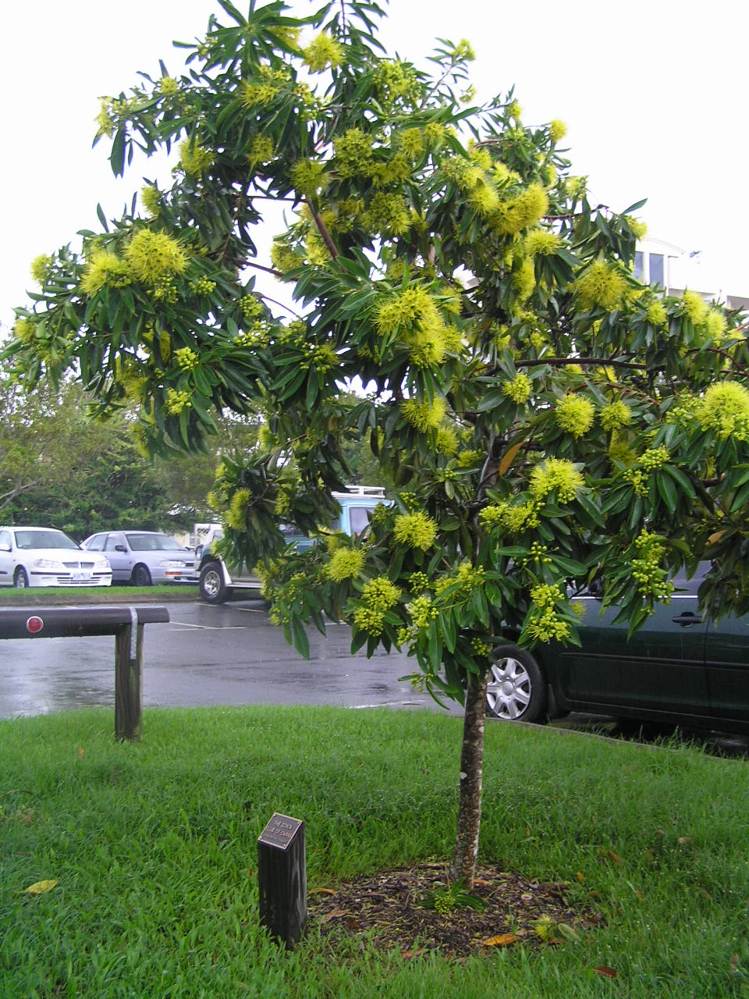

THE ZONTA GOLDEN PENDA

Members may recall 4 years ago when the Esplanade redevelopment was taking place the club paid for a “ Golden Penda ” to be planted opposite Cairns Base Hospital car park with a plaque.

WELL HERE IT IS ALIVE AND WELL !.

