Zonta Club of wynnum redland area


Newsletter

August 2005

Area 5 District 24
Charter Date: 25 September 1981

wynnumredlands@zontadistrict24.org
PO Box 132, CAPALABA QLD 4157

President: Jill Maclachlan (H: 3821 0951)
Correspondence/Minutes: Margaret Finegan (H: 3207 4442)
Newsletter: Philippa Fenwick (H: 3822 5093)

Date | Events / Date Claimers
8 August | Dinner meeting at Steven’s by the Bay
20 August | Card Making – Barbara Carters
9 September | Fashion Parade - Shangri-La Gardens
Sept/Oct | UN Spring Walk (date to be confirmed)
7-9 October | District Conference
October | UN Dinner
2006
10 March | International Women’s Day Dinner
24-29 June | International Conference – Melbourne

Dinner Meeting Details
DATE  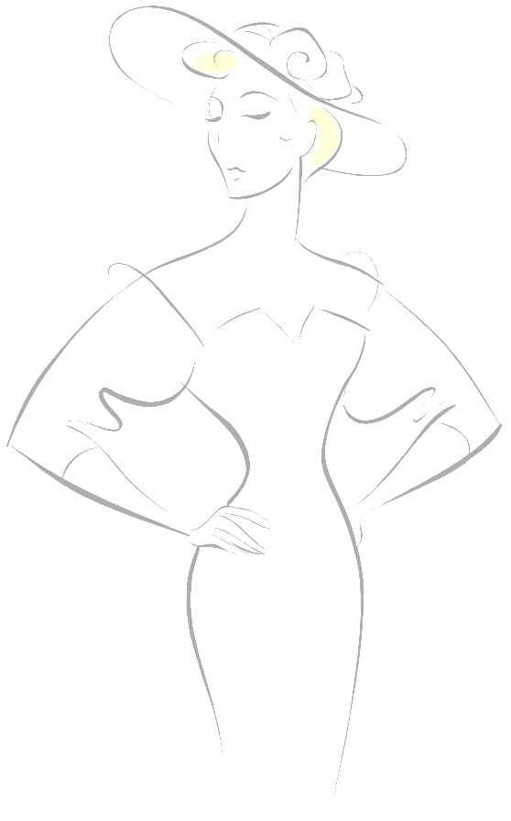  Fashion Parade  Saturday 9 September  Shangri-La Gardens  1969 Wynnum Rd  Wynnum West | MONDAY, 8th August  Apologies must be made to Jo Hieatt on 3396 3295 (bus) or 3398 4817 (home) by Thursday 4th August.
VENUE | Steven’s by the Bay  Pacific Resort Hotel, Middle St
COST | $20
TIME | 6.30pm for fellowship,  dinner 7:00pm.

Zonta Birthdays

Phyllis Pledger – 6 August
Marilyn Steenland – 30 August

Jill’s Journal

The past month has been a busy one in Zonta for many of us. The dinner at Parliament House in July with our Zonta International President was excellent. President Mary Ellen Bittner spoke of our mission to advance the status of women worldwide and the progress of our international service projects. In particular Mary Ellen referred to discussions she'd had with Sakena Yacoobi about the Afghan Institute of Learning and Sakena's devotion and determination for the cause of women in her country.

A presentation of one of our ZI cards was made to Mary Ellen, so she is now very well aware of our club and its activities. Diane Harmsworth managed to get around all the tables and obtain 180 signatures for the card. Quite an achievement!

On July 16 we had another successful card making session at Barbara Carter's home. Special thanks go to Barbara who has expertly guided us in the current production of some 200 cards. If you want to purchase any, or perhaps one of the framed cards, please see Jo.

Barbara Wills produced a wonderful Christmas Dinner on 23 July. Although the numbers were low it was such a good evening. Many thanks to Barbara and Tony for their friendship and hospitality. Thank you for the very generous donations of a ham from Jo Hieatt, a hamper from Janet Mylne and to Sandra Franklin and Chris Scott for helping to peel vegetables!

Please bring along your friends and family and support our Fashion Parade on 9 September. We are hoping to get as many people as possible. The meal looks great and so do the fashions provided by Marie Trueman Boutique. It should be an excellent evening.

The Office of Women has produced a coffee table commemorative book highlighting Queensland women who shaped the State politically, socially and economically. This helps mark the milestone of the centenary of women gaining the right to vote in our state, and the 40th anniversary of indigenous women's right to vote. You can get more information on this book, "Great Queensland Women" by Heather Grant, from www.women.qld.gov.au/womenvote.

Yours in Zonta,
JILL

Service and Fund Raising

Many thanks go to Barbara and Tony Wills for the great Christmas in July function all who attended had fun.

There will be 2 motions at the next meeting the first will be for $500 to Barbara Carter for supplies for cards, the second $1000 to Maybank for to supply three outdoor settings. More information will be available at our next meeting.

We need full support for the Fashion Parade on Saturday 9th September. We are aiming for 100 ticket sales. So start calling up friends, as we should like to start selling tickets at our next meeting.

Please bring along womens toiletries as this month we are collecting for Maybank.

Janet

PR & Programme

Status of Women

We have received three applications for YWPA and are delighted with the quality of them the committee will be processing the information and selecting the winner shortly.

Best wishes
Jill Allen

United Nations Committee

The UN committee is unchanged this year. A planning meeting is scheduled to occur prior to the next dinner meeting, so I hope to date claim a number of events.

Spring Walk
A waterside walk of 5 kilometers is planned so that participants can gain personal sponsorship. The best dates are Sept 18, Oct 2 or 16. I hope to get a decision from the members at the next meeting.

UN dinner will occur in October and a theme is to be announced.

IWD dinner is to be held on Friday 10 March 2006, venue to be announced, investigations continue for a suitable venue and guest speaker.

Marilyn Smith and myself are going to see 'Moolade' on 7th August.

Until next time
Judith Trevan-Hawke

